**Shoutout User StreamerBot Extension**

**Created by Vengey**

**[** [**https://twitter.com/ItsVengey**](https://twitter.com/ItsVengey) **|** [**https://www.twitch.tv/itsvengey**](https://www.twitch.tv/itsvengey) **|** [**https://vengey.carrd.co/**](https://vengey.carrd.co/) **]**

**How to Import into StreamerBot…**

**STEP 1: *Copy this LONG string***



**STEP 2**: ***Click Import in Streamerbot***

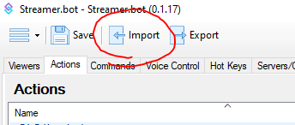

**STEP 3**: ***Paste the code into “Import String”, an action and command will show up, then hit “Import”***

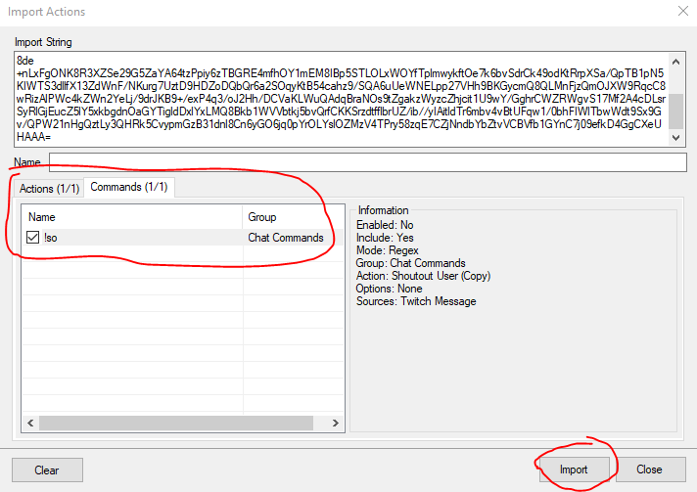

**STEP 4**: ***Go to your Actions tab; look for an action called “Shoutout User” and double click the sub-action labeled “Twitch Announce” and customize it to be a message that better suits you!***

Here is a full list of variables you can inject into your message

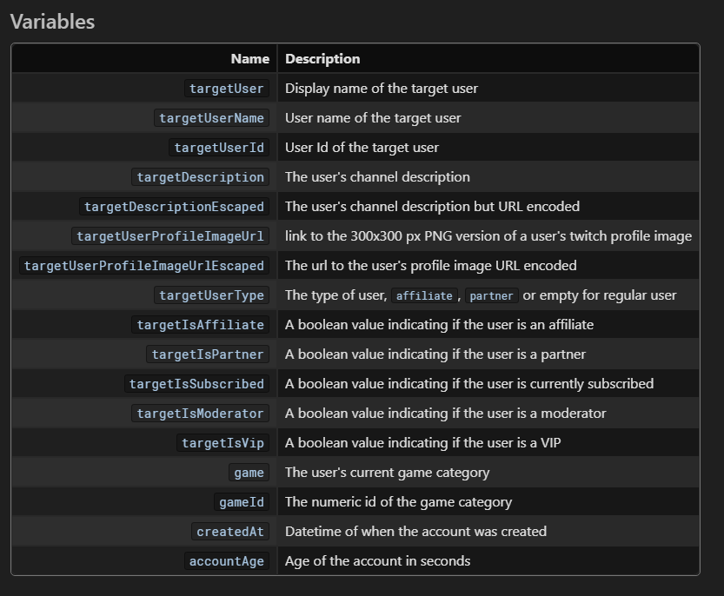

***And that’s it! The !so command should already be loaded in so all you have to do is use !so <username> in twitch chat and it will do BOTH an IN CHAT shoutout AND the new Twitch integrated shoutout as well!***